<!DOCTYPE html>

<html>

<head>

<title>Introduction</title>

<link href="https://fonts.googleapis.com/css?family=Average|Istok+Web:400i" rel="stylesheet">

<style>

body{

background: url(BG.jpg) no-repeat center center fixed;

}

table{

margin-top: 50px;

}

h2{

Font-Family: 'Istok Web', Sans-Serif;

margin-left: 40px;

}

p{

Font-Family: 'Average', Serif;

margin-left: 40px;

}

li{

Font-Family: 'Average', Serif;

margin-left: 40px;

}

td{

border-radius: 8px;

height: 600px;

width: 1250px;

box-shadow: 10px 10px 5px #000;

background-color:#fff;

opacity: .70;

}

</style>

</head>

<body>

<center>

<table>

<tr>

<td>

<h2>Primary Information</h2>

<p>Name: Jared Gerolao Abelilla</p>

<p>Age: 18</p>

<p>Birthday: Febuary 27, 2004</p>

<p>Email: abelillared@gmail.com</p>

<p>Address: Block 4 Lot 6 San Lucas Subdivision. Habay 1 Bacoor Cavite.</p>

<br>

<h2>Hobbies</h2>

<ul>

<li>Playing Games</li>

<li>Watching Anime</li>

<li>Workout/exercise</li>

<li>Cooking</li>

<li>Coding</li>

</ul>

<br>

<h2>Favourite Food</h2>

<ol>

<li>Ramen</li>

<li>Nilagang Baka</li>

<li>Protein Pancakes</li>

<li>Watermelon</li>

<li>Kiwi</li>

</ol>

<br>

</td>

</tr>

</table>

</center>

</body>

</html>

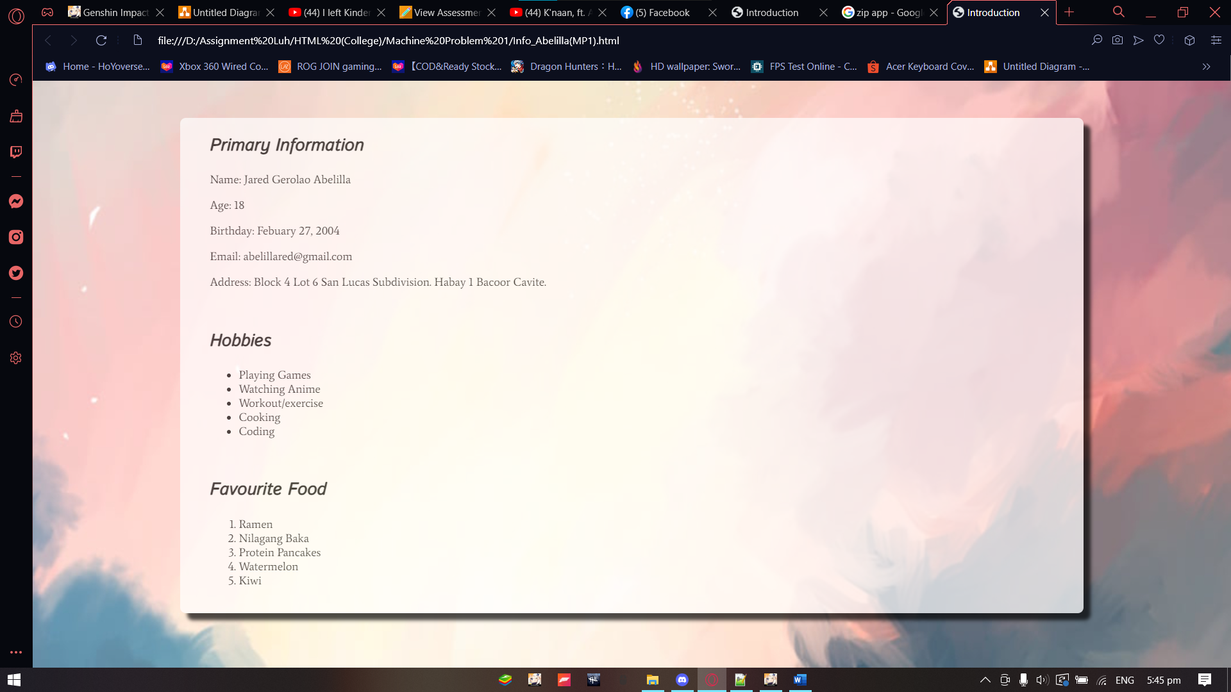

Background Name: BG

